Nicholas Primiano

njp2119

10 October 2016

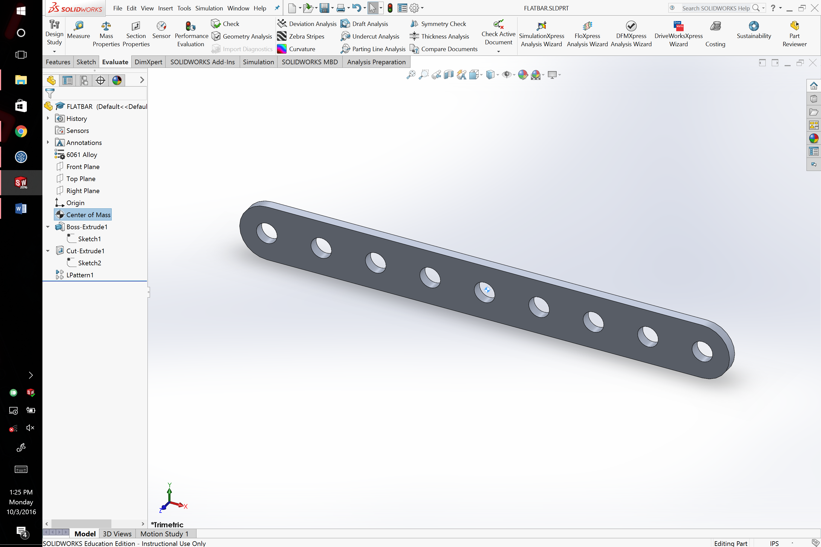

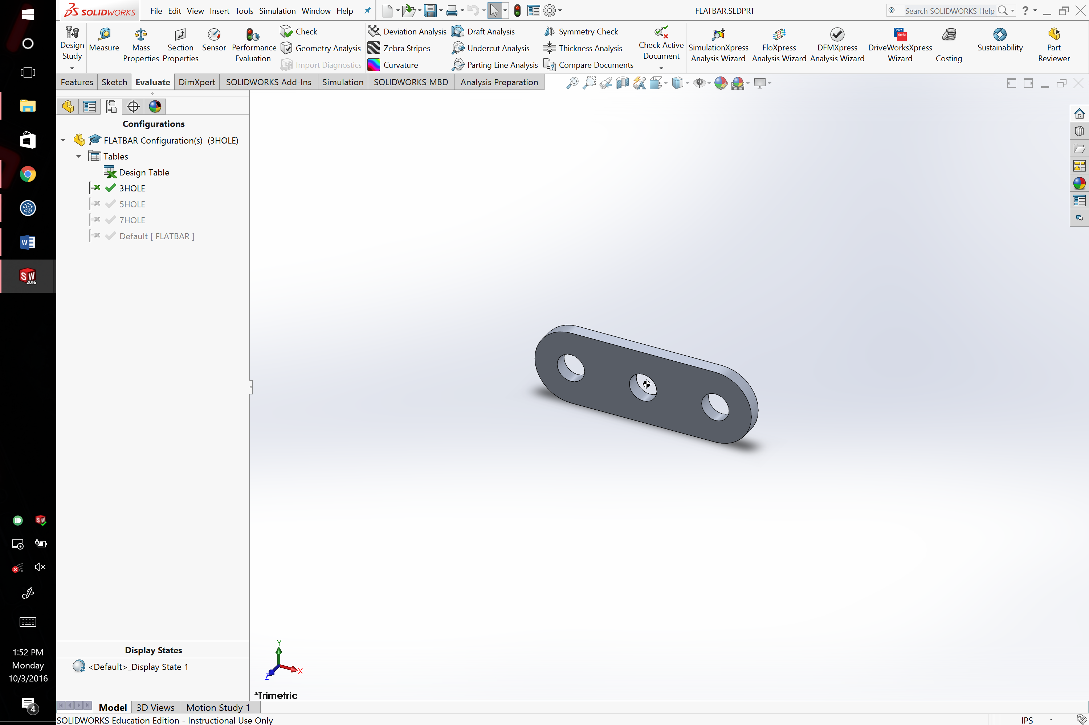

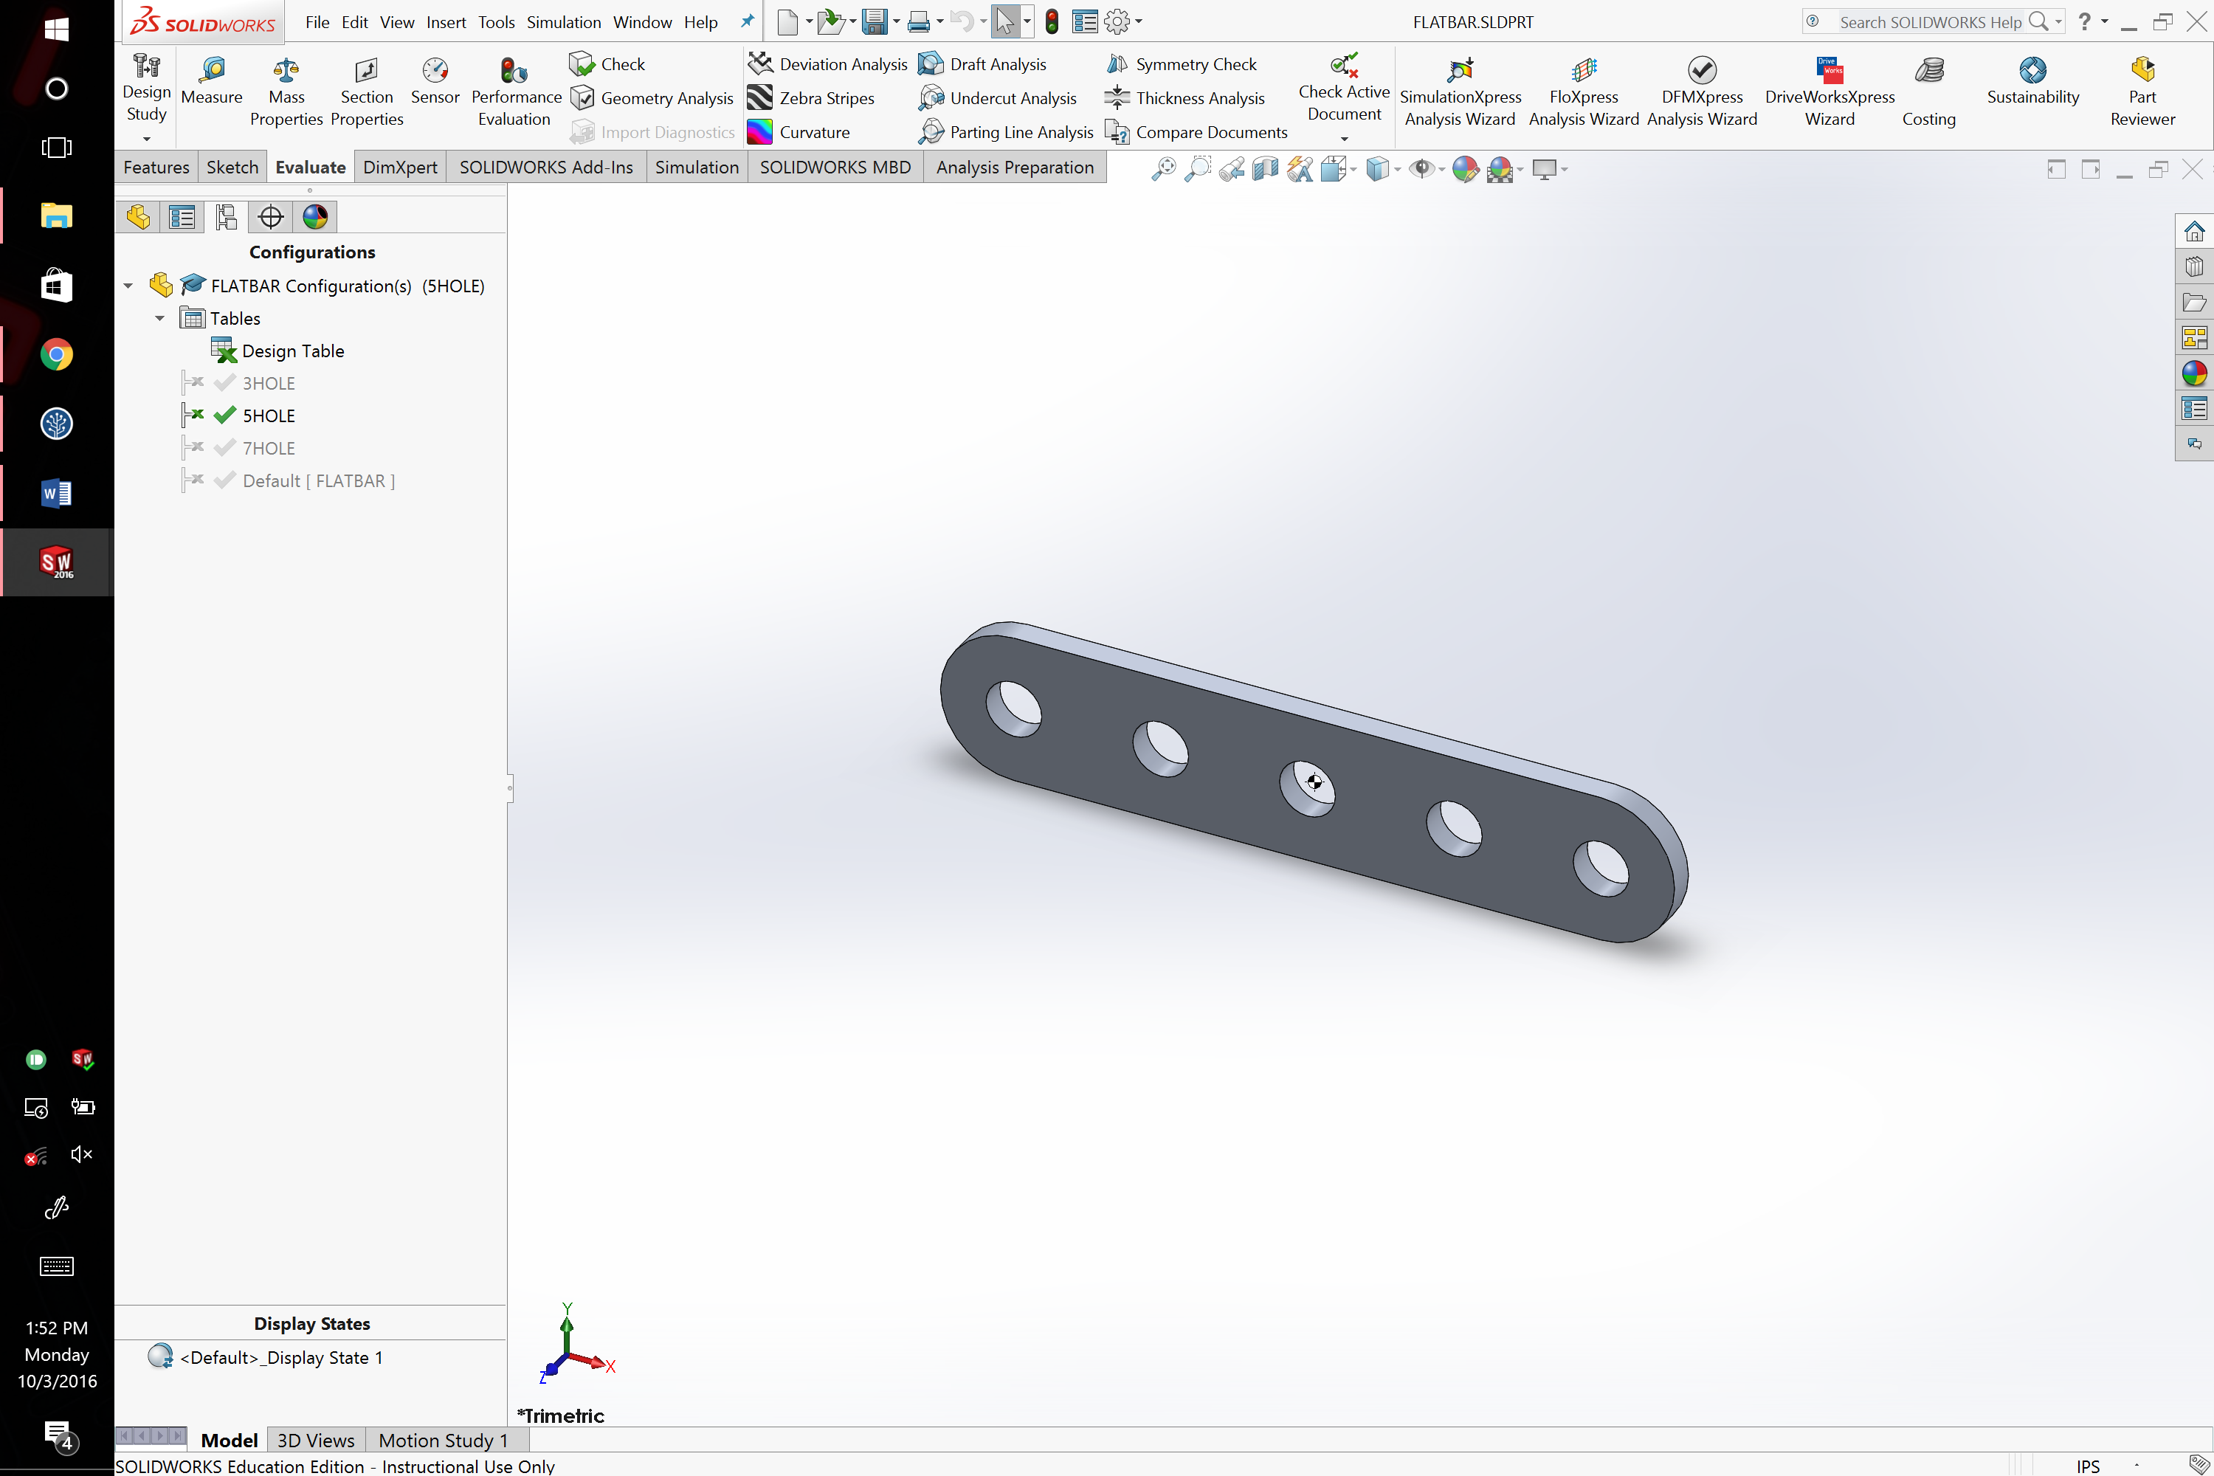

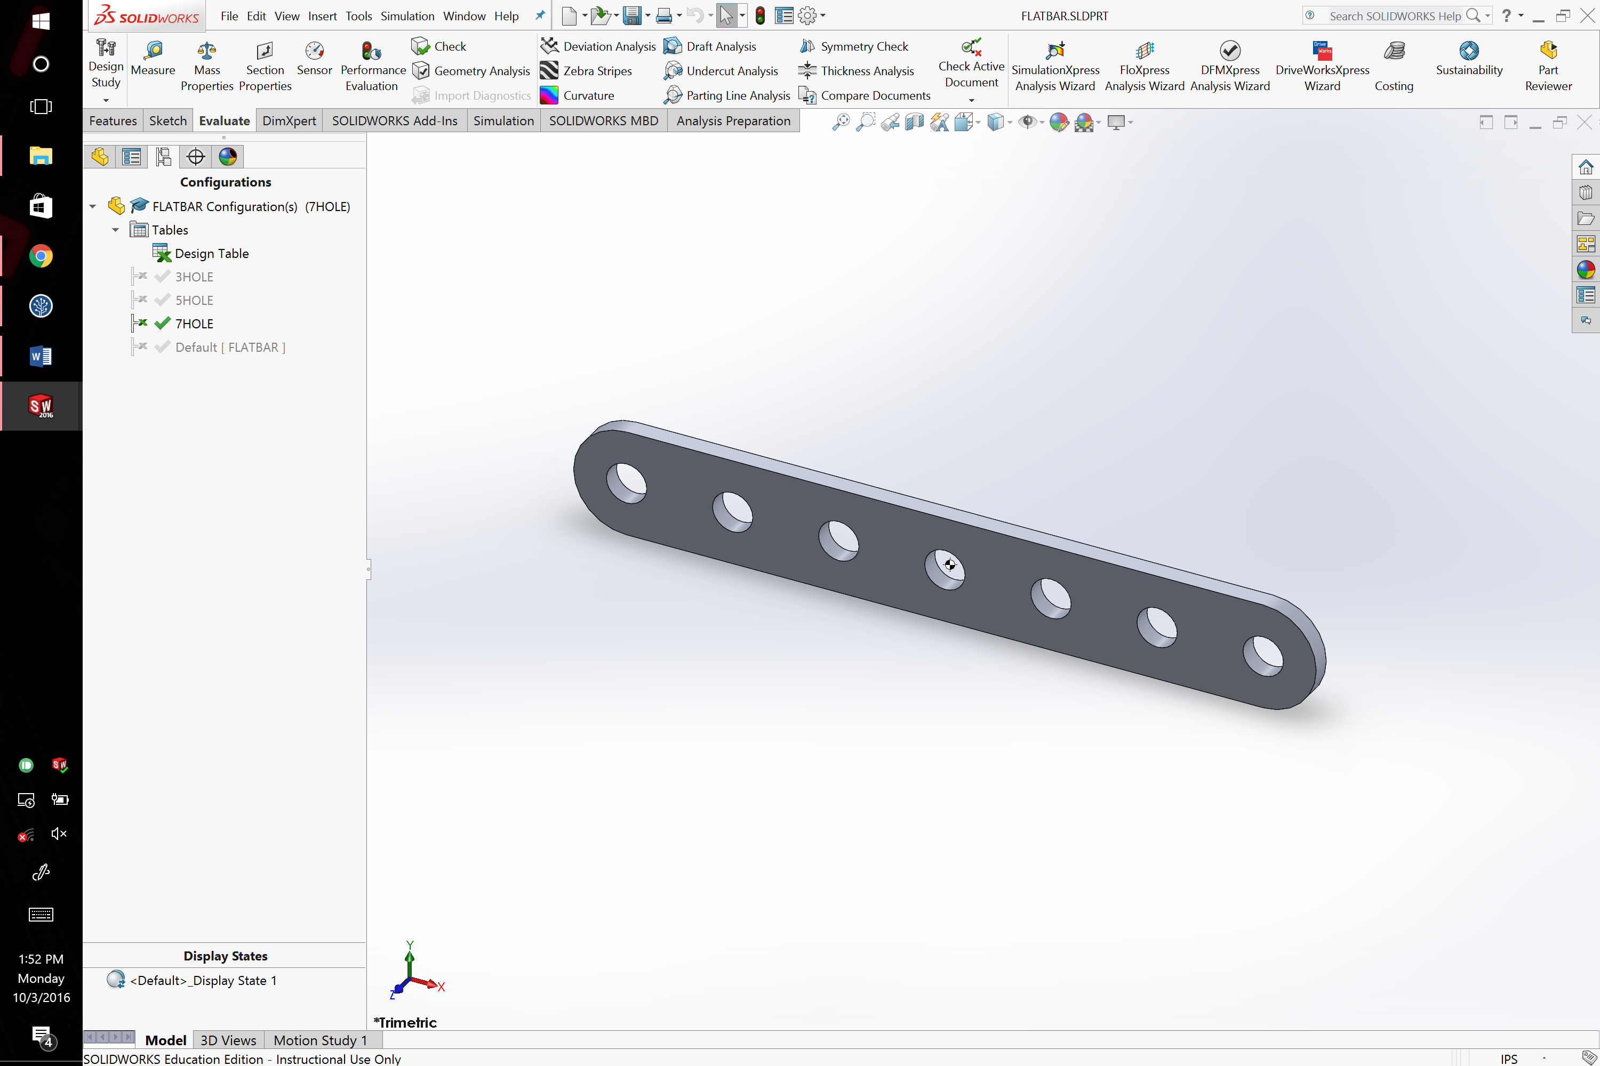

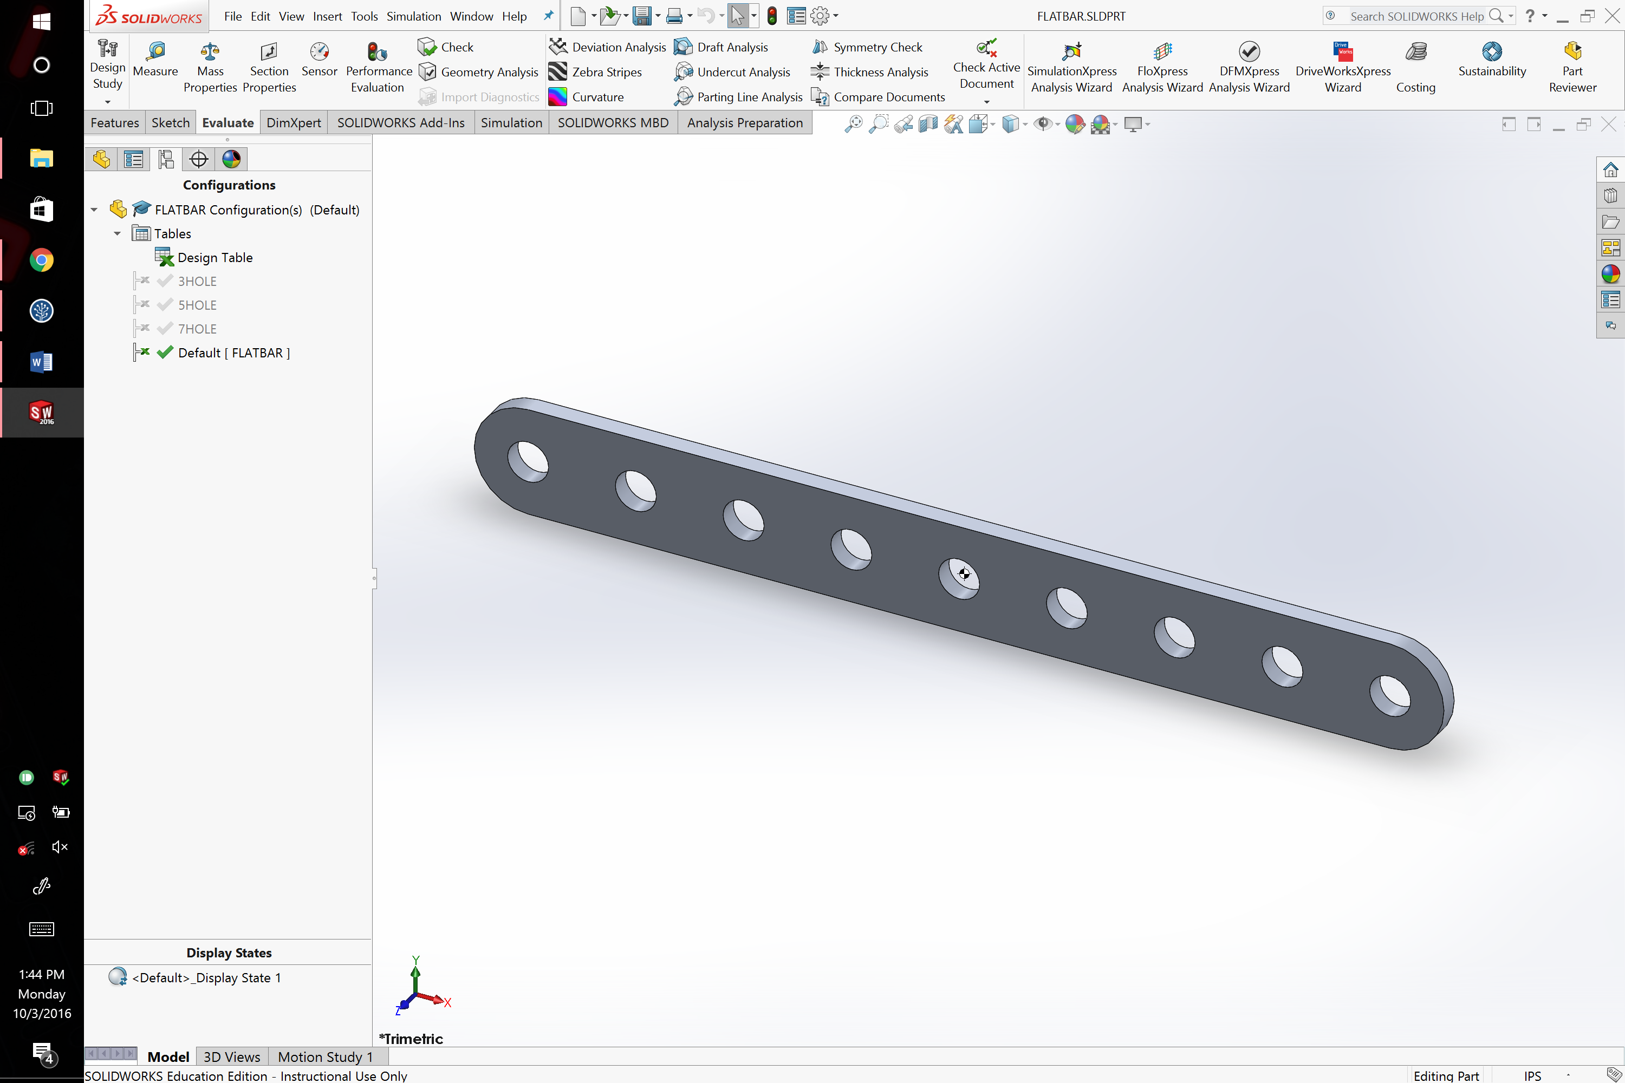

1. A design table is useful for defining objects with a different number of repeated features. This prevents the need for multiple SolidWorks files and allows the designer to quickly scale up or scale down the object. Example: Power stirps with a different number of sockets.